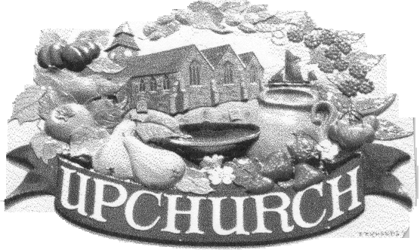

UPCHURCH PARISH COUNCIL

Clerk to the Council:

Mrs W Licence
14 Trapfield Close, Bearsted, ME14 4HT
Tel: 01622 739324 e-mail: clerkupc@outlook.com

To All Members of the Council, Press and Public

Members are hereby summoned and notice is given that a meeting of the General Purposes Committee of Upchurch Parish Council will be held remotely on Wednesday 20th May 2020 at 7.30pm when it is proposed to transact the following business:

- Apologies for absence
To receive and accept apologies for absence.
- Declarations of Interests
Members are invited to declare disclosable pecuniary interests and other interests in items on the agenda as required by the Upchurch Parish Council Code of Conduct for Members and by the Localism Act 2011

*************************************************************************************************************
Public Time ~ This is a concessionary short session and will be limited to thirty minutes.

*************************************************************************************************************
- Paddock and Recreation Ground
To receive an update
- Allotments
To receive an update
- Burial Ground and Churchyard
To receive an update
- Highways and Street lighting
To receive an update
- Footpaths
To receive an update
- Environment
To receive an update
- Any other matter arising
- Date of next meeting: Wednesday 17th June 2020 at 7.30pm

W Licence

Wendy Licence (Mrs)
Clerk to Upchurch Parish Council Dated this 15th day of May 2020

Please contact the Clerk for login details to this meeting

Legislation allows for meetings to be recorded by anyone attending. Persons intending to record or who have concerns about being recorded should please speak to the Clerk.

